**Home Page:**

<http://wantro.com/creative2/home/index.php>

Footer changes (update map and contact information)

**Design page:**

<http://wantro.com/creative2/design/design.php>

Image should be open on full screen.

Home button didn’t work properly

Video Content Repeated again and again

**Consultancy Page:**

<http://wantro.com/creative2/Consultancy/consultancy.php>

Animation on header issue (not working on mouse movement)

**Promotion Page:**

<http://wantro.com/creative2/Promotion/Space-Ape-Games.php#>

Links on heading not direct to next page

Rocket is missing

**Marketing Reach:**

<http://wantro.com/creative2/Marketing/grid>

Wantro on last tile is missing

<http://wantro.com/creative2/Marketing/>

Button Text is not readable

**Testing Page:**

<http://wantro.com/creative2/Testing/index.php>

Change images

Buttons not work properly. (Didn’t change text and image, only change background)

**Website development:**

Direct to about us page

**Game development:**

<http://wantro.com/creative2/game-development/>

Links direct to genuine website links

**Software development page:**

<http://wantro.com/creative2/software-development/>

The movement of circle is not proper

C# and vb.net heading missing from thumbnail

Change the Java page content:

Extensive experience in java development, rich client presentation technologies and frameworks such as Play, JSF, Spring MVC, Struts 2, AJAX, GWT, Prototype, Velocity, WebWork, Tiles, Groovy/Grails, and Swing, as well as Eclipse-based RCP and RAP frameworks. We build truly engaging user experiences through single-page applications using HTML5 and modern JavaScript web frameworks such as AngularJS, Knockout, Backbone.js, and Boilerplate JS.

Wantro has experience using different Java-based application servers and servlet containers with JBoss, Tomcat, and Jetty as the most frequently used. We have experience using WebSphere, WebLogic, JRun, Glassfish and Resin. In addition to Web/JEE applications, Coherent teams have worked on Eclipse plugins, OSGi-based applications and hybrid solutions.

Our team also has experience with Java messaging technology (JMS) implementations such as ActiveMQ and JBoss Messaging, and with portal technologies such as Liferay.

**About us Page:**

<http://wantro.com/creative2/about-us/about-us.php>

Image and text become visible after refresh.

High loading time

First image and text not visible properly

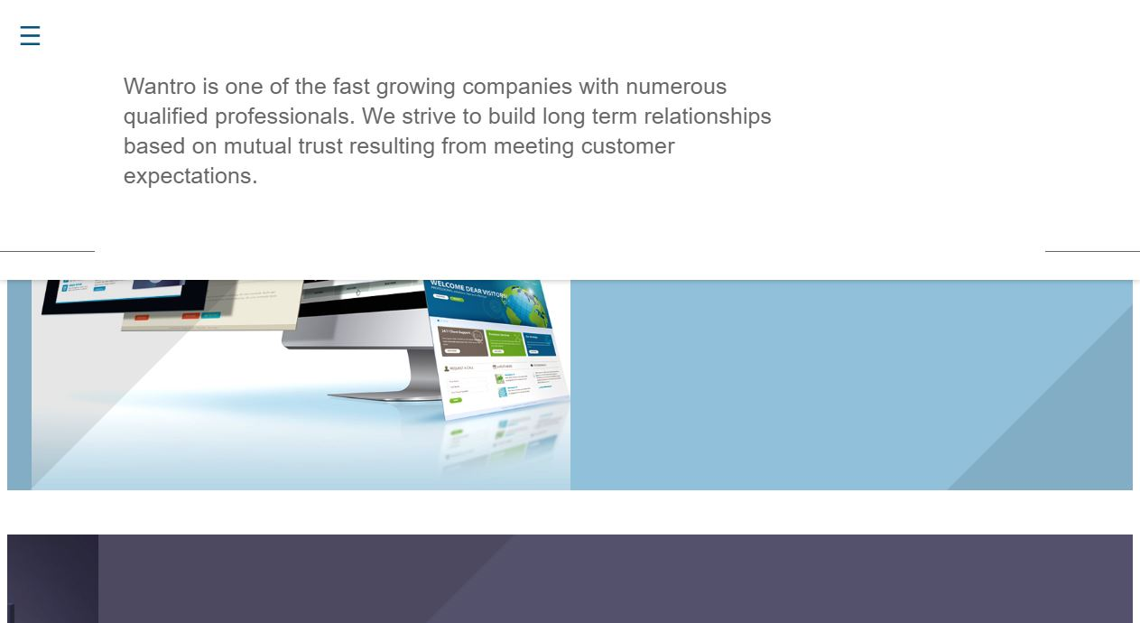

**Mobile Development Page:**

<http://wantro.com/creative2/Mobile-development/index.php>

Left right moving icon error

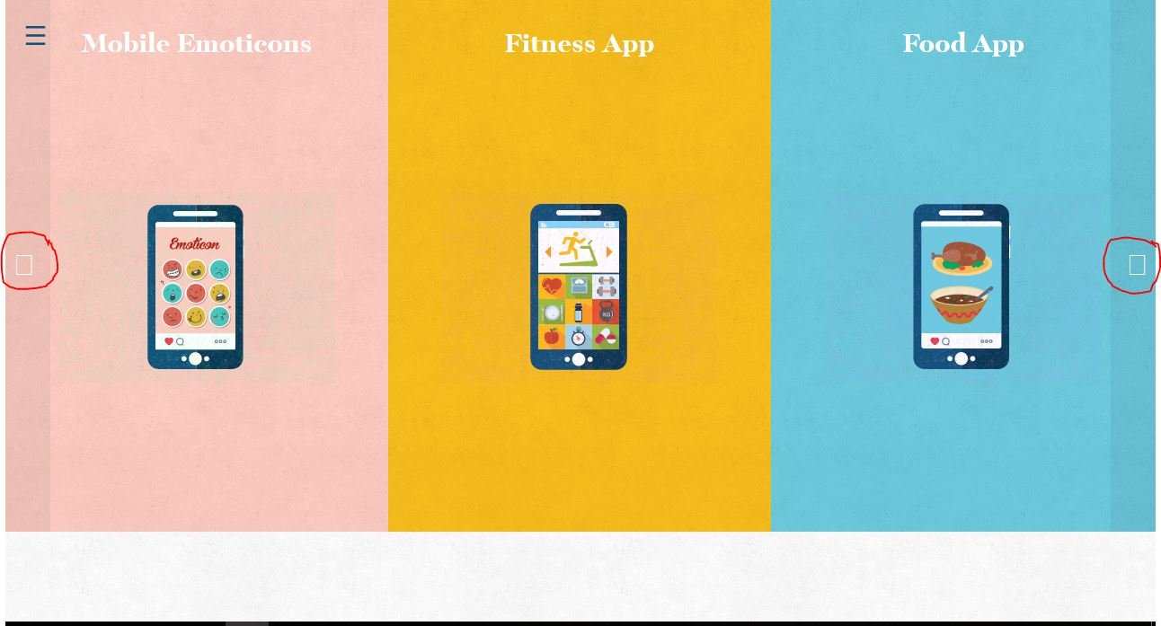

**Events Page:**

Done but Not Uploaded.

**Pages in progress:**

Services

Team

Kickstarter

Portfolio

Development